ECOEA-R Report to the May 2015 Advisory Council from Kathleen Purdy, Representative
Contact information: ecoearetired@yahoo.com

During the NEOEA Representative Assembly in Twinsburg on Saturday, April 25, 2015, I was very intrigued by the organizational structure and accomplishments by their dedicated members and staff. Over the years, as a District Leader, I have attended many statewide RA’s, however, this final RA of the year presented me with a challenge.
My first challenge was while listening to the Legislative Committee Report and reading the printed report, it mentioned “it had been over a year since they approved the recommendations to appoint their members to serve in each of the Senate Districts as liaisons to NEOEA.” Then I thought back to the “Assignment of Ohio House Districts to OEA Districts (2012-2022)” handout from the OEA-R Advisory Council during the Fall of 2013 in which names and contact information of ECOEA-R members for these House Districts were submitted. ECOEA’s Ohio House Districts are HD 1, HD 5, HD 48, HD 49, HD 50 and HD 98. The policy behind having retirees on the committees were to be driven by regular networking and communication with the OHIO HOUSE members. Is this happening because several of my suggested appointees haven’t heard from the OEA as a follow through to continue building a relationship?
My next challenge was to embrace and offer support to the East Liverpool Education Association Members who addressed this RA along with their Crisis Coordinator with communicating with our district retirees on what is needed for the ELEA. This unit is within the East Central Ohio Education Association. March 27, 2015, the East Liverpool School Board spoke briefly to the media saying they had offered their last and best offer to the Association. Any suggestion on how retirees could support the ELEA, at this crucial time, is most appreciated. Below is a picture with the President and Vice President of ELEA after their remarks to the NEOEA Representative Assembly joining me in the Atrium?
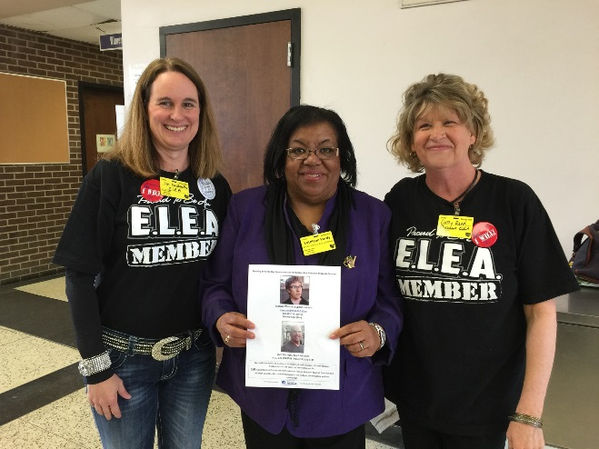
Thank you so much for your suggestions and friendship throughout this year. Kpurdy

