ECOEA-R Report to the March 2015 Advisory Council from Kathleen Purdy, Representative
ecoearetired@yahoo.com
The activities surrounding our Retirement Workshop produced almost 3 lifetime membership. We had almost 65 members and guests in attendance on Saturday, February 7, 2015 for this breakfast program. The District Officers, Program Committee Members and OEA-R VC worked very cooperatively in making this a relaxing and informative meeting. Below, I am congratulating the recipient, Linda M., with our thank you Speedway gas card for purchasing a membership. She is retiring from Perry Local Schools and we certainly are pleased by her wise decision. The other member was Katherine W., from the North Canton Middle School.
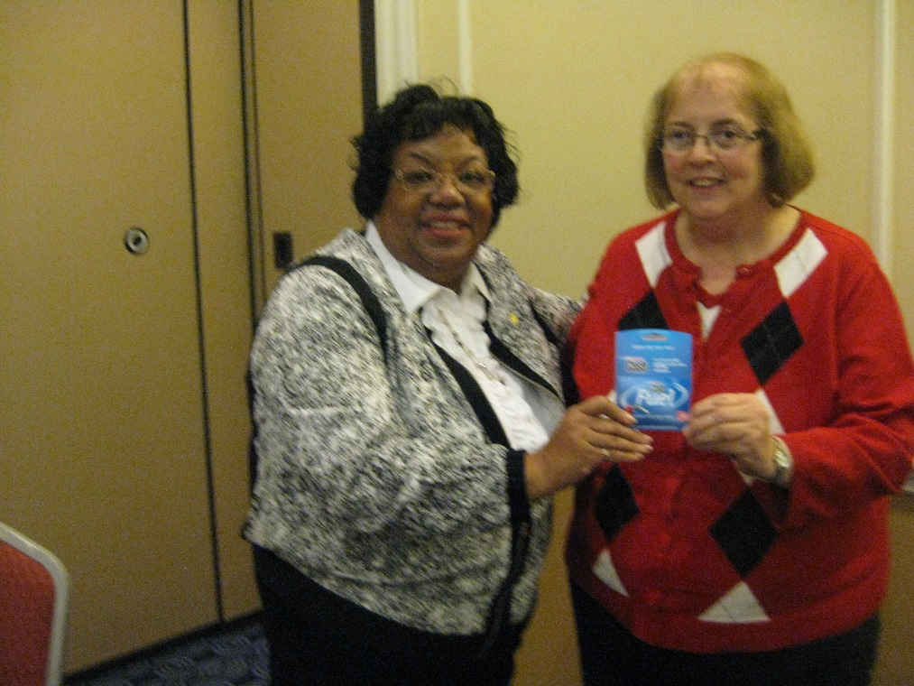

I successfully have submitted all paperwork necessary from our OEA-R grant which included the Banquet Order with voucher, the Sign In Sheets and copies of the Evaluations from the Workshop at our March Advisory Council Meeting.

The most recent copy of the OEA-R Newsline captured the excitement surrounding our National Education Association’s President Lily receiving the retirees at the Ohio Education Association Doris L. Allen Minority Caucus December Dinner. This annual dinner welcomes all members to participate through membership and positive support. Contact Martha Mitchell, President for more information.

Submitted by Kathleen Purdy, ECOEA-R Representative

