OEA-R Advisory Council District Report from ECOEA-R Kathleen Purdy 12/4/14
Happy Holidays from East Central Ohio Education Association Retirees!
Our plans toward the OEA-R sponsored Retirement Workshop are in process. We are offering three (3) different workshops: Late Career/STRS; Mid-Career/STRS; SERS Members scheduled for Saturday, February 7, 2015. Emphasis on the benefits of membership in retirement would be presented along with a great breakfast buffet, door prizes and much more. Color copies for the Retirement Workshop were available at the November 22, 2014 District RA.
During the November 22nd District RA, I offered an opportunity to raise monies using a Gift Basket Raffle for retirees. The theme of “Tour of Italy” was so profitable that I have chosen it again for the OEA-R basket. OEA-R delegates in attendance were Sally Smith and Kathleen Purdy. Below is a photograph of the OEA-R display table with 2013 CPEA President, Dr. Geneva Parker standing with me.
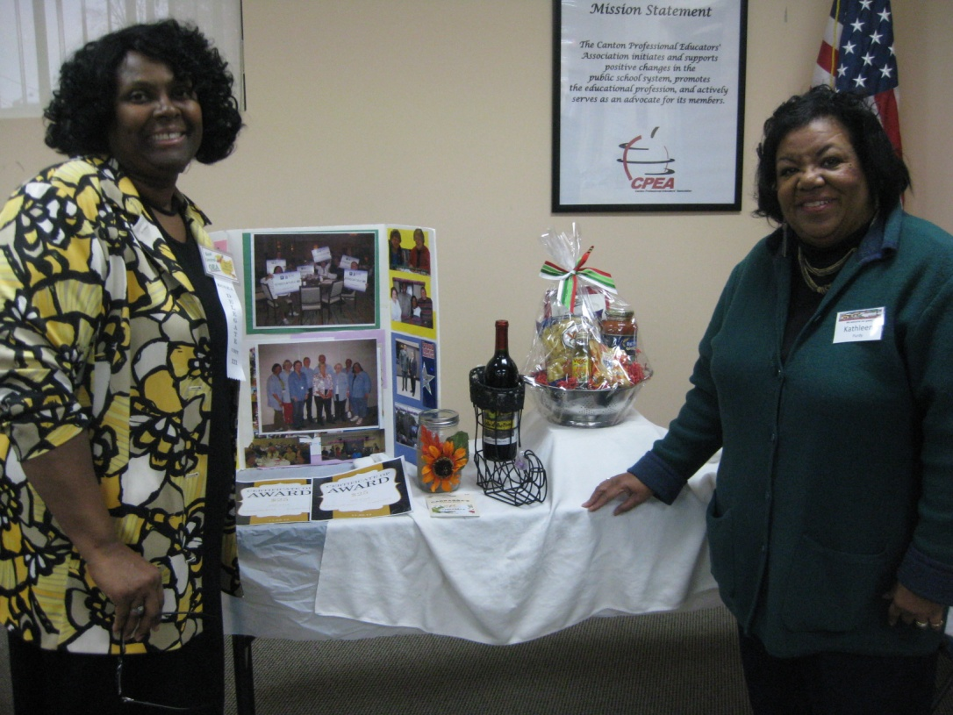
Our Holiday social event was held in Wayne County at the Pine Tree Barn. We welcomed Carol Meyers and spouse, Bill. She most recently served on the EC for the District as the Stark #3 Rep, retiring a few months ago from teaching. Table favors were holiday string card holders. Our next social will be Summer 2015.
Happily submitted by ECOEA-R Kathleen Purdy

